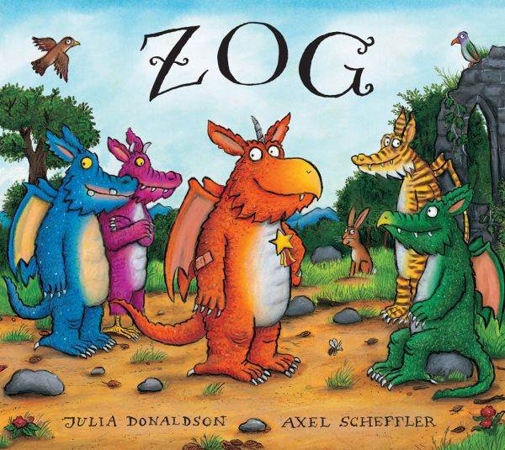
Foundation Home Learning week beginning Monday 11th May 2020
Zog by Julia Donaldson
(Story can be found on YouTube and is also currently on BBC iPlayer)
Zog is the keenest dragon in school. He's also the most accident-prone. Luckily, a mysterious little girl always comes by and patches up his bumps and bruises. But will she be able to help him with his toughest test: capturing a princess?
Before reading the story, on a piece of paper, write some words to describe dragons. Maybe you think they’re green, scaly and breathe fire. Do the same for describing a princess – maybe you think they wear pretty dresses and crowns.  After reading or watching the story, what do you notice? Did Zog and Pearl match your descriptions? Do you like the characters more or less because of this? | Design your own dragon! Will it have sharp teeth and claws, wings, horns, long tail, scaly skin? Label all of its features and give it a name. | Read the first page: “She taught young dragons all the things that dragons need to know.” What do you think dragons need to know/learn at school? What do you think Zog will have to do in order to win a golden star? What sort of things do you do that get a ‘well done’? Maybe its being helpful? Or trying really hard at something and not giving up? Maybe you could make some stars at home and give them out to your family when you think they deserve a ‘well done’!
Practise your pencil control in the attached Dragon Pencil Control sheet. | Can you spot all the rhyming words? How many words can you think of that rhyme with star? Write them in a list. Try to spot some of the digraphs that you know: ow, igh, ee, ar, er, oo, sh | Practise some maths skills with the attached Zog Maths sheet. Draw some more sums of your own.
If you have some spare toilet rolls or egg boxes at home, maybe you could have a go at making your own dragon! See some examples in the attached Dragon Craft sheet. Craft activities are great for developing hand strength. Cutting, picking up small pieces, gluing, folding etc are all great exercises to develop fine motor control. | Talk about the different ‘people who help us’ such as police, firefighters and nurses as well as paramedics. Look closely at what they wear and why. Princess Pearl doesn't like silly frilly dresses. Design a uniform that she could wear as a flying doctor. What features might it need? For example, fire resistant (being around dragons), warm (for when she is flying about), brightly coloured so people can see her coming to the rescue. | Write your own story about the dragon you designed and named. Will it be like Zog where your dragon learns new skills and meets a new friend? Or will your dragon have a different kind of adventure? When writing, always say your sentence first before you write it. It’s impossible to write stories if we can’t first tell them! Maybe you’d prefer to ‘write’ your story using pictures? We call this a story map. Then tell your story to someone in your family.

Additional information:
Phonics – To support your child’s phonics, please listen to them read regularly. In addition, you may wish to download the app ‘Teach Your Monster to Read’. You can also find excellent activities on phonicsplay.co.uk and phonicsbloom.com. By the end of Foundation, children reach the end of phase 3 so when choosing games to play it is worth practising both phases 2 and 3. A YouTube channel has also been created for parents wishing to support their children with phonics at home. This can be found here:
https://www.youtube.com/channel/UCP_FbjYUP_UtldV2K_-niWw/featured

I highly recommend looking up Mr Mc’s phonics videos here:
https://www.youtube.com/channel/UCTcZnvuTeovlznioLRo0GOA

