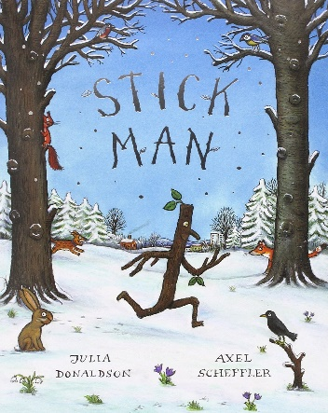
Foundation Home Learning week beginning Monday 4th May 2020
Stick Man by Julia Donaldson
(Story can be found on YouTube and is also currently on BBC iPlayer)
"Stick Man lives in the family tree with his Stick Lady Love and their stick children three."
But it's dangerous being a Stick Man. A dog wants to play with him, a swan builds her nest with him. He even ends up on a fire!
Will he ever get back to the family tree?
Find some sticks either in your garden or whilst you’re out for a walk to make your own Stick Man. You could use string to tie your sticks together and even add leaves for hair, just like in the book. Will your Stick Man go on an adventure? What will happen? Make up your own story! | Practise your pencil control with the attached sheet (Stick Man pencil control). Try your best to follow the lines. The more you practise, the easier it will become. | Stick Man lives in the family tree. Do you think anyone else lives in the tree? In your garden or while you’re out for a walk, go on a bug hunt and see how many different bugs you can spot.
Find a few sticks and try to put them in size order, from smallest to biggest. Which is the shortest? Which is the longest? How many did you find? If you put them all in one long line how far does it reach?  Use one of your sticks to measure things around the house. How many sticks long is your table? Your sofa? How many sticks long are you?!  Complete the attached adding activity (Stick Man addition). | Can you spot all the rhyming words? Can you practise writing some of them? How many words can you think of that rhyme with stick? Write them in a list. Try to spot some of the digraphs that you know: ck, ee, ar, igh, ch, ee, oa | In the story, Stick Man floats along the river. Try experimenting with different things you find around the house and in the garden to see what floats. Can you have a guess, before you put it in the water, whether it will float or sink?? What do you notice? If you are lucky enough to live near a stream or river, maybe you could play a game of pooh sticks!
Look carefully at the pages in the story or on the screen as you read/watch the story. Can you see what the weather is like? What do you notice? What season is it at the beginning of the story? Can you spot signs of the seasons changing? What season are we in now? How do you know? Can you draw a tree in each of the 4 seasons? | Stick man gets used in many different ways in the story. How many uses can you think of for a stick? Really use your imagination! Maybe a wand? A pencil? A rocket?! Can you write a list? | Ask a grown up to write ‘It’s the right kind of twig to weave into my nest.’ with each word on a separate piece of paper or using post it notes. Can you read the words and put them in the right order? Then practise writing the sentence.

Additional information:
Phonics – To support your child’s phonics, please listen to them read regularly. In addition, you may wish to download the app ‘Teach Your Monster to Read’. You can also find excellent activities on phonicsplay.co.uk and phonicsbloom.com. By the end of Foundation, children reach the end of phase 3 so when choosing games to play it is worth practising both phases 2 and 3. A YouTube channel has also been created for parents wishing to support their children with phonics at home. This can be found here:
https://www.youtube.com/channel/UCP_FbjYUP_UtldV2K_-niWw/featured

I highly recommend looking up Mr Mc’s phonics videos here:
https://www.youtube.com/channel/UCTcZnvuTeovlznioLRo0GOA

