Sign in for the first time
- Go to classroom.google.com and click Go to Classroom.
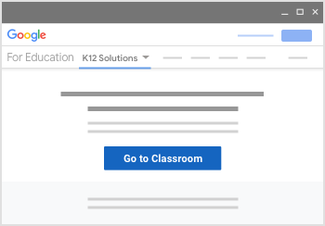
- Enter your child’s username (the email that ends@stpiusxchelmsford.co.uk) and click Next.
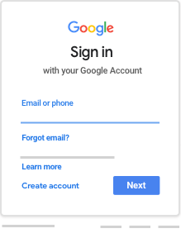
- Enter your child’s password and click Next.
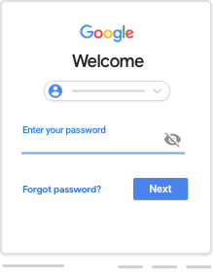
- If there is a welcome message, read it and click Accept.
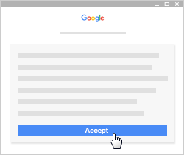
- Click I’m A Student.
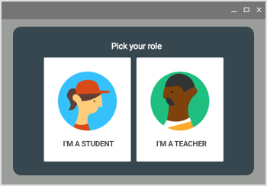
- Click Get Started.
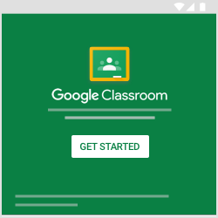

Join a class with a class code
- At the top, click Add Join class.
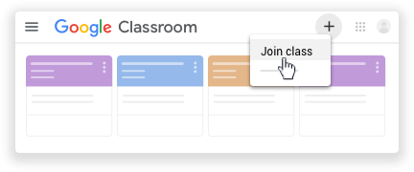
- Enter the class code your teacher gave you and click Join.
A class code consists of 6 or 7 letters or numbers. For example, hjhmgrk or g5gdp1.
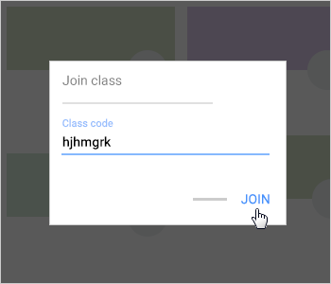

- Now you are in the classroom you can see work uploaded by your teacher on the Stream, click on links, upload your own photos and write comments.

Any questions or concerns, please email the school office.

