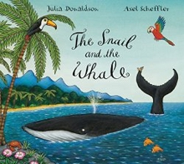
Foundation Home Learning week beginning Monday 27th April 2020
The Snail and The Whale
(Story can be found on YouTube and is also currently on BBC iPlayer)

One tiny snail longs to see the world and hitches a lift on the tail of a whale. Together they go on an amazing journey, past icebergs and volcanoes, sharks and penguins, and the little snail feels so small in the vastness of the world. But when disaster strikes and the whale is beached in a bay, it's the tiny snail who saves the day.

Read or listen to the story. Can you hear the rhyming words? What do you notice? Sound out and try to write some of the rhyming words. Can you underline the part of the word that rhymes? Can you spot ai, ck, oo, igh and ng? Can you write the words that have those sounds? What other words can you think of that use those sounds? | Make a salt dough snail! Mix 1 cup of flour with ½ a cup of salt. Gradually add ½ a cup of water until you get a dough consistency. Then roll the dough into a snail shape. Bake in the oven at 100 degrees for 2-3 hours. When baked and cool you can paint your snail. You could even try making a whale! | Can you create a snail trail with your finger? If you have paint at home, try some finger painting. Create a looping curling trail! Can you write a message? Or maybe you could make a trail with your finger in some sand, or even flour (if you have some!) on a work surface! Or a wet finger on a blackboard.
There are lots of describing words in this book! Can you spot them? Do you have a favourite? How would you describe the snail? Create a mind map (see example below) using words to describe the snail. | The rock at the beginning of the story is described as being ‘as black as soot’. This is called a simile. Can you think of and write some similes to describe things you can find in your house or garden? Maybe you can see something that is as green as grass, or as yellow as the sun. Draw a picture to match your similes. | Can you make up your own story about two animals that go on an adventure together? How do they meet? Where do they go? What do they see? What happens? Draw a picture and either write your story or write a sentence about it. Remember a capital letter, finger spaces and full stop.
How many seagulls are there on the first page (double spread)? If one flew away how many would be left? If another seagull flew in, how many would there be? If there are 10 snails on the rock and half of them go for a ride on the snail, how many snails will be left on the rock? How many penguins does the snail sail past? How many fish can you count in the whole story? | Ask your grown up to write out one of the sentences on post-it notes or pieces of paper, with just one word on each piece of paper. Then it’s your job to read the words and put them in the right order. Can you then write the sentence too? | Even though the snail felt small, he managed to help the enormous whale when he was stuck on the beach. Can you think of ways that you help others? Maybe you could help set the table for your grown-ups. Maybe you could help tidy away your toys. Even though you’re small, you make a BIG difference to those that know you!

Example:
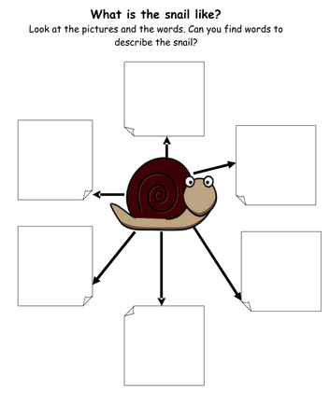

Additional information:
Phonics – To support your child’s phonics, please listen to them read regularly. In addition, you may wish to download the app ‘Teach Your Monster to Read’. You can also find excellent activities on phonicsplay.co.uk and phonicsbloom.com. By the end of Foundation, children reach the end of phase 3 so when choosing games to play it is worth practising both phases 2 and 3. A YouTube channel has also been created for parents wishing to support their children with phonics at home. This can be found here:
https://www.youtube.com/channel/UCP_FbjYUP_UtldV2K_-niWw/featured

