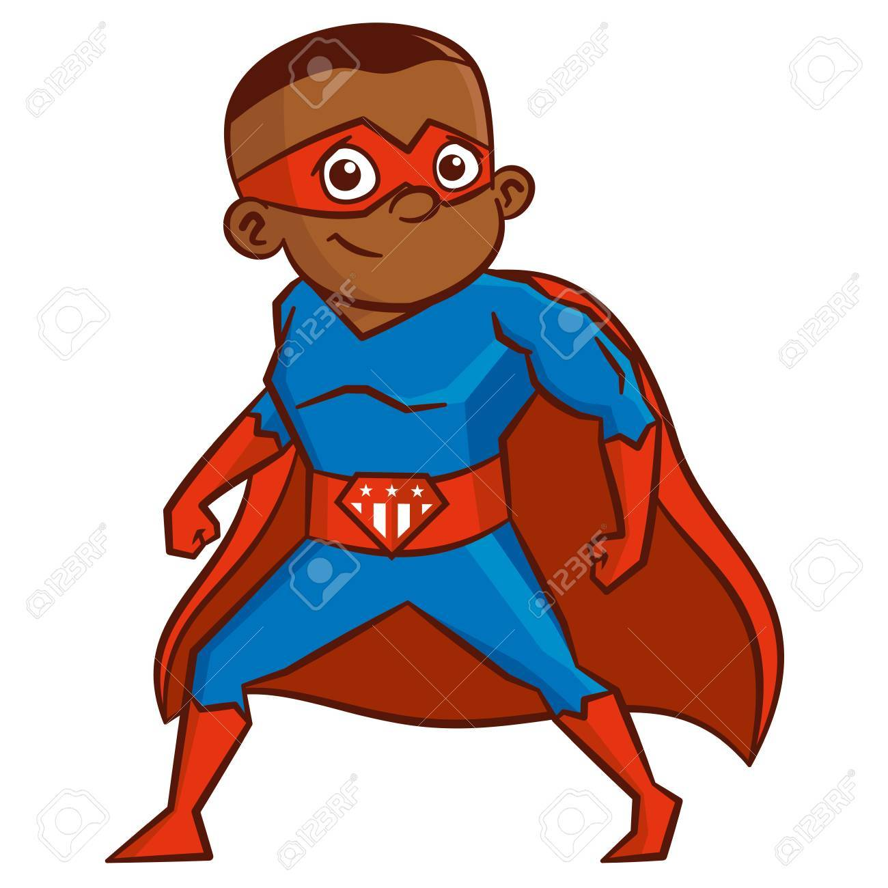

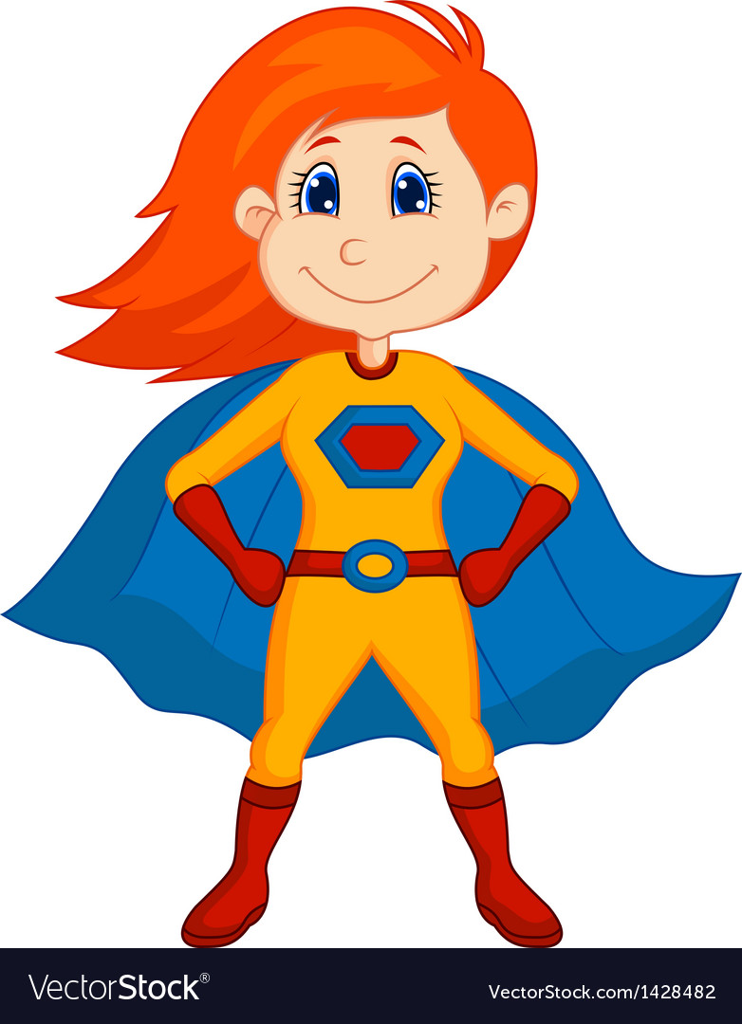
As Computer Technologists we will:
- Sign an Acceptable Use Agreement
- Learn how to log on
- Explore how to stay safe online
- Learn how to search for pictures online
- Use the iPads and Chromebooks
As Musicians we will be:
- Develop our understanding of pulse, rhythm and pitch.
- Develop our ability to sing as a group.
- Explore percussion instruments.
As Athletes we will:
- Explore different ways of travelling.
- Explore how movements can express different emotions.
- Develop our hand-eye co-ordination, special awareness and large and small ball skills

As Artists we will:
- Draw and paint self-portraits
- Create collage portraits
- Study the work of Andy Warhol and make portraits in his style
As God’s Children we will:
- Learn about the domestic church
- Discover God loves and cares for everybody and never stops loving us
- Look at how we’re created in the image of God
- Look at the family of God in Scripture

Year 1
Autumn
Superheroes
As Writers we will:
- Look at Supertato by Sue Hendra
- Secure our use of capital letters, finger spaces and full stops
- Write captions for pictures
- Retell stories
- Write information texts about local superheroes
- Write poetry with onomatopoeia
In Topic (History and Geography) we will:
- Look at how we’ve changed since we were born
- Study our local area and describe it using words and pictures
- Use maps
- Discuss what we like about our local area and how it could be improved
- Meet some local Superheroes!
In PSHE we will:
- Understand what keeps our bodies healthy
- Learn about hygiene routines
- Recognise what we’re good at
- Discuss change and loss
- Talk about our goals

As Scientists we will:
- Look at animals including humans
- Draw and label our bodies
- Learn about the five senses
- Identify and describe animals
- Learn about Herbivores, Carnivores and Omnivores
As Mathematicians we will:
- Secure our understanding of numbers 1-10
- Count, read and write from any number, forwards and backwards
- Find one more and one less
- Use language greater, fewer, equal, more, less
- Compare and order groups and numbers
- Use number lines

