Using Google Classroom
- Go to classroom.google.com. It is best to use Google Chrome as your internet browser when doing this.

- Sign in using GSuite details – email me (s.denbigh@stpiusxchelmsford.co.uk) if you do not have them. Type them carefully because they do work.
- Your child should use the username and password written in the front of their reading record. Following their username, they should use the email address: @stpiusxchelmsford.co.uk.
E.G. 14BenS@stpiusxchelmsford.co.uk
- Your child should then use the ‘GSuite’ password assigned within their reading record. Make sure to use correct capitalisation when entering details.
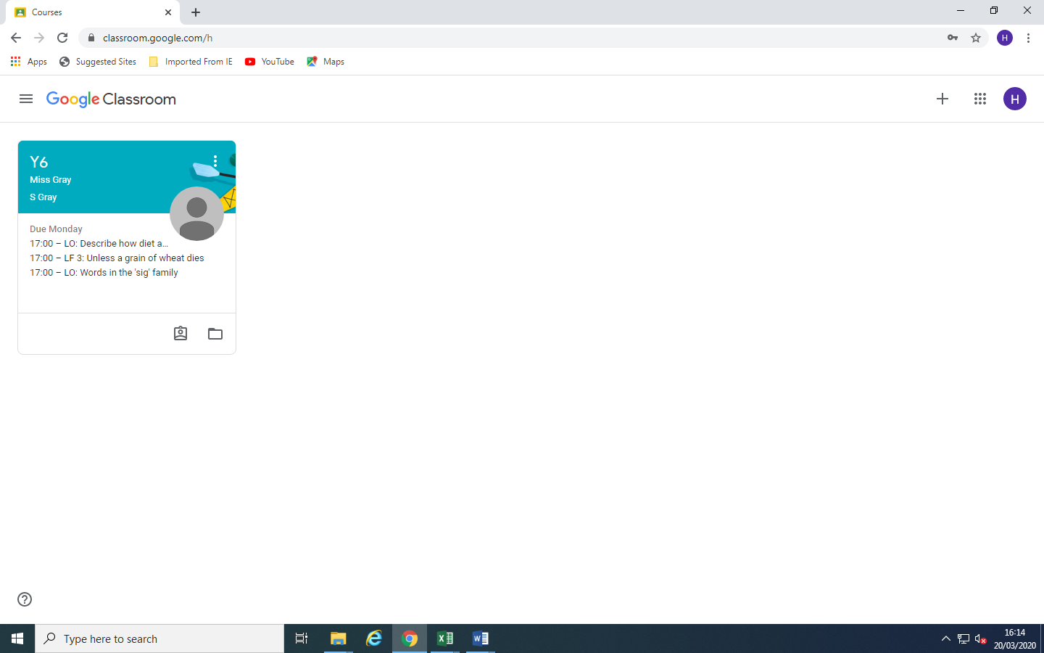
Click to enter our classroom.

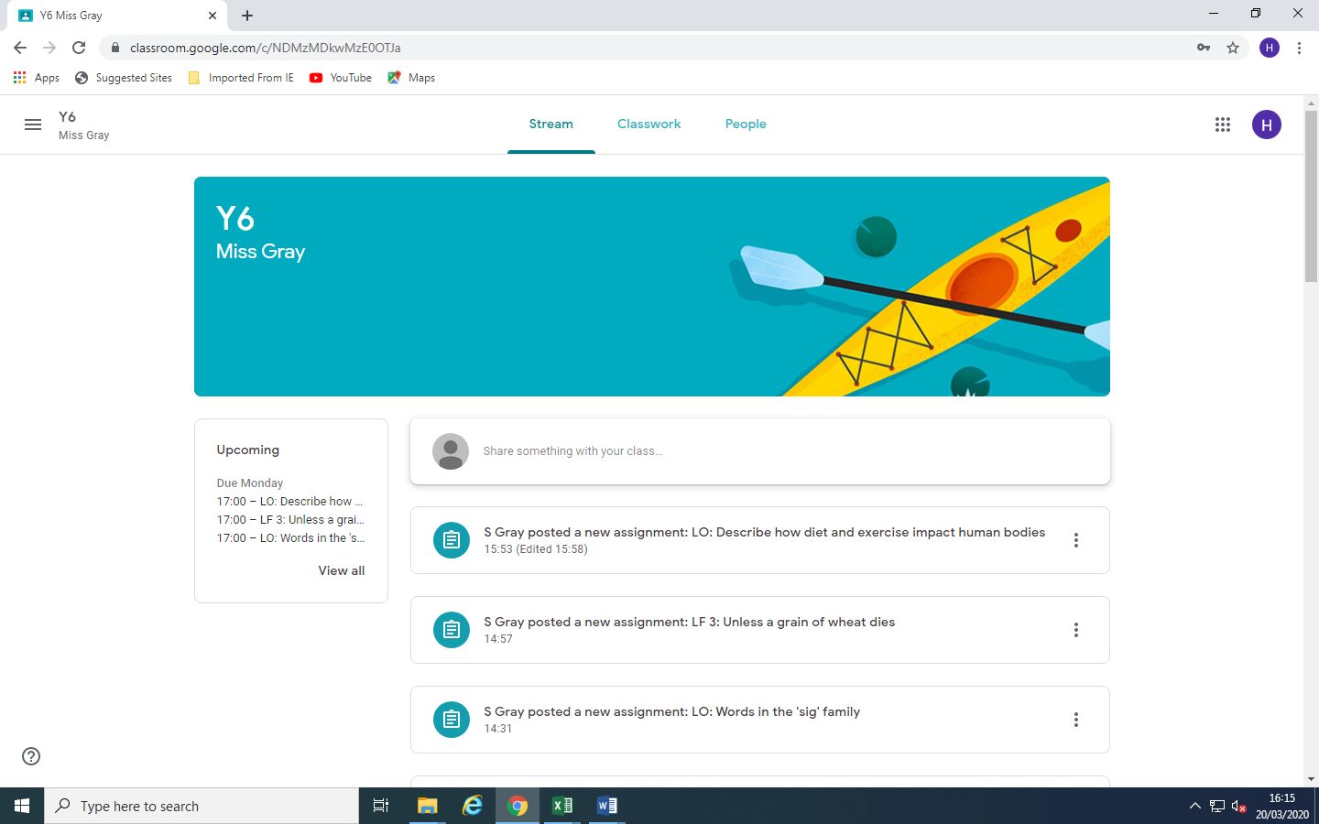
Click to see classwork.
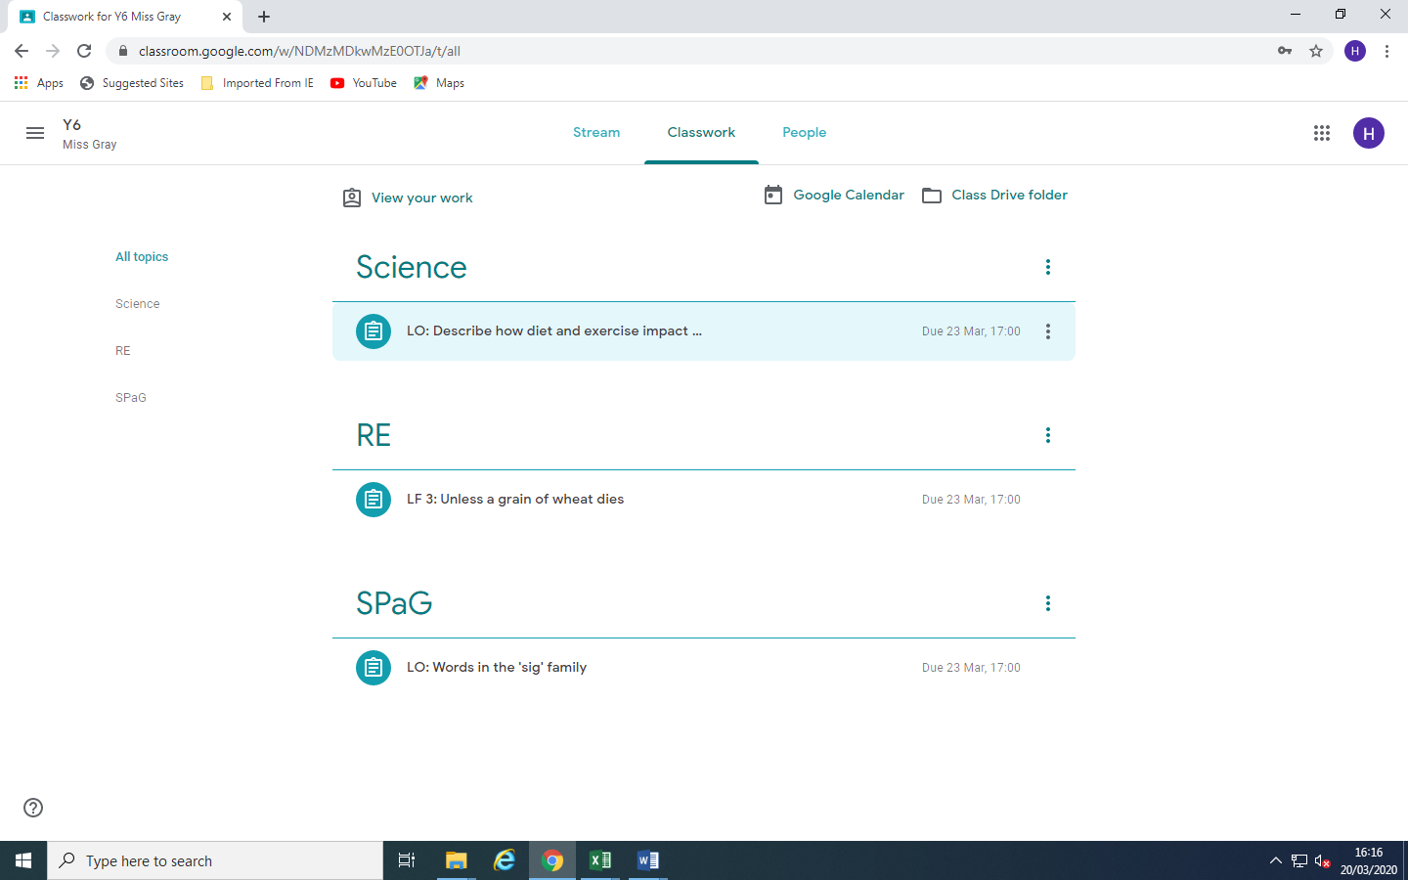
Click on the work you wish to open.

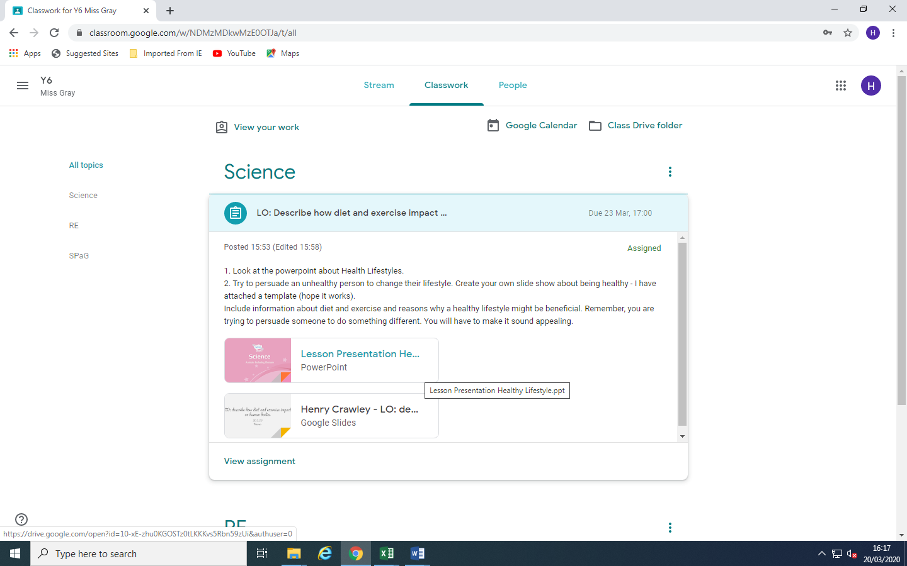
View the assignment in full.

Scroll through the document.
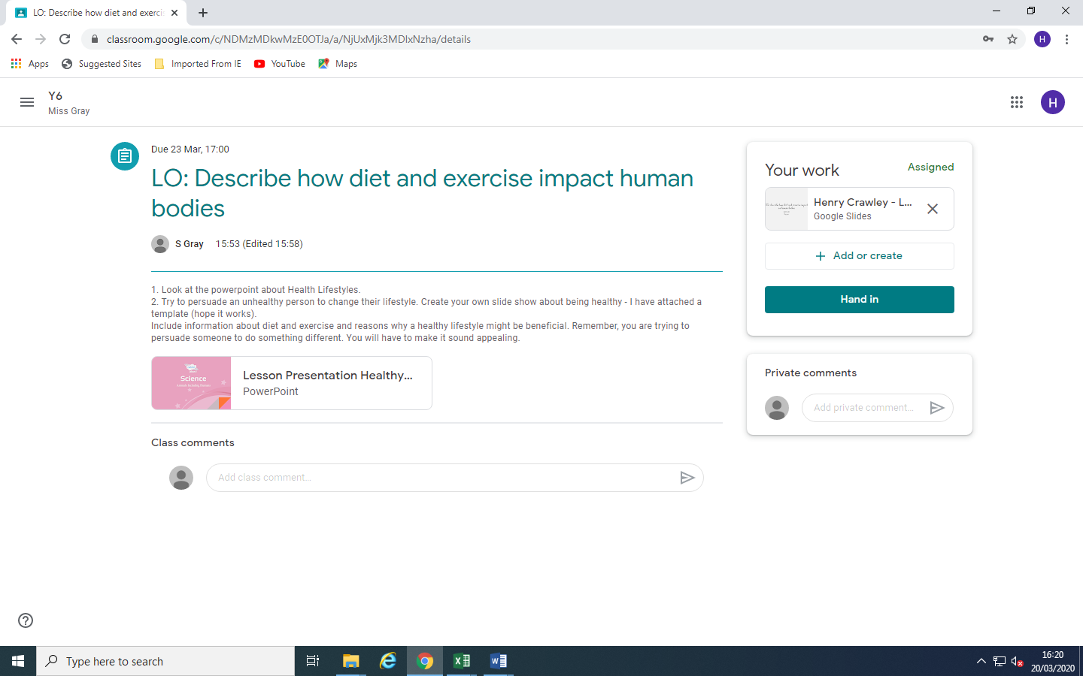
Click to open the attachments.

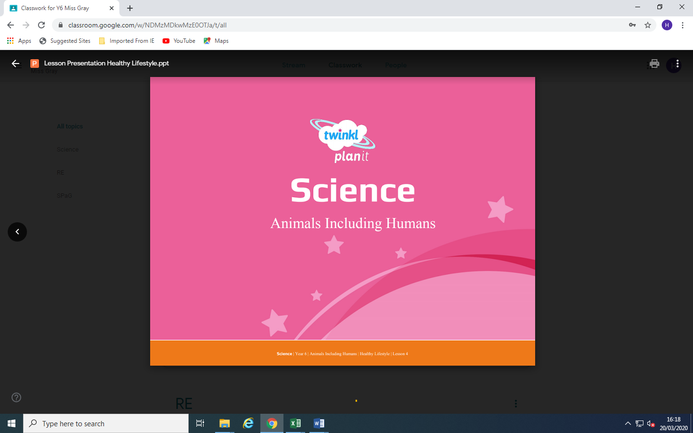
Click on the back button to return to the task.

This will open new document.
This will open a template.
Read the instructions very carefully.

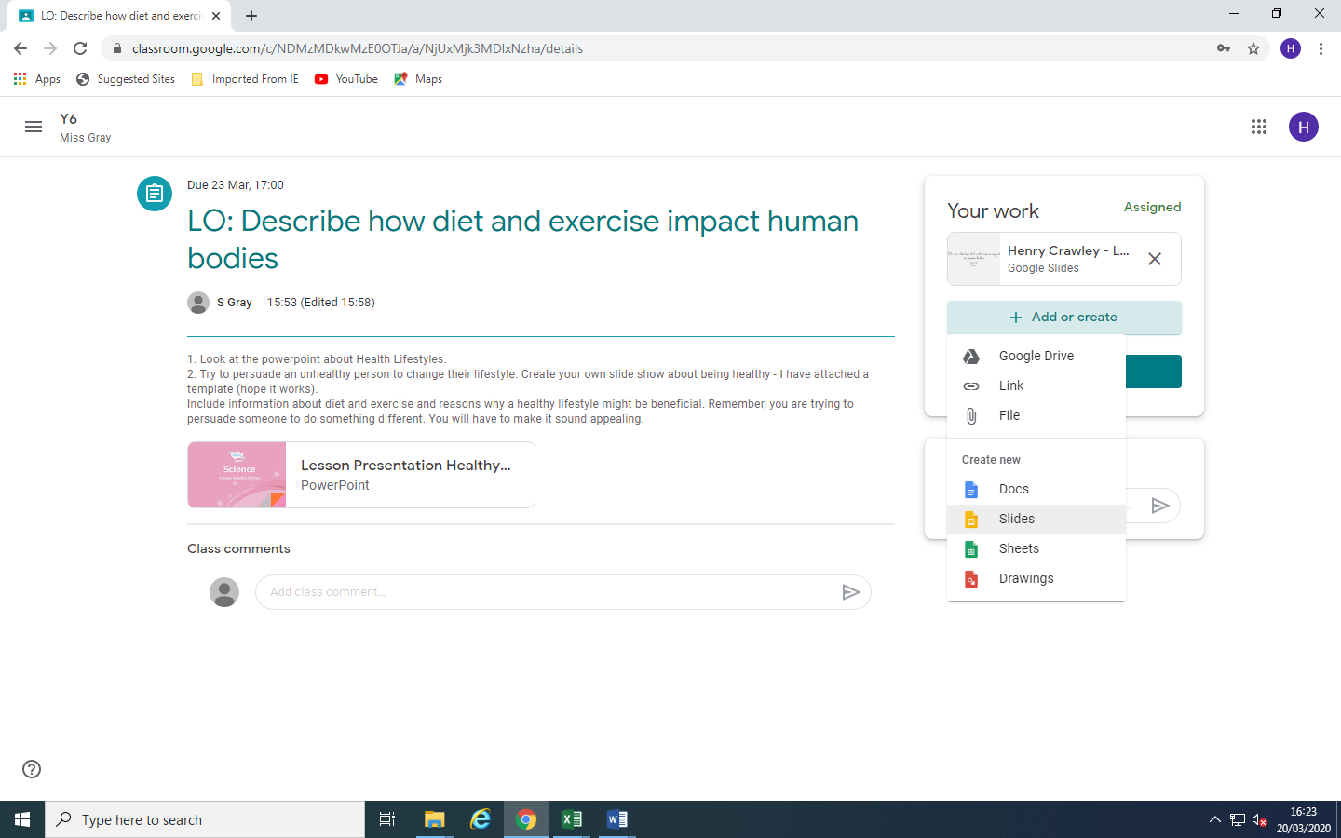
This will open new document. Select the type you think is most appropriate for the task.

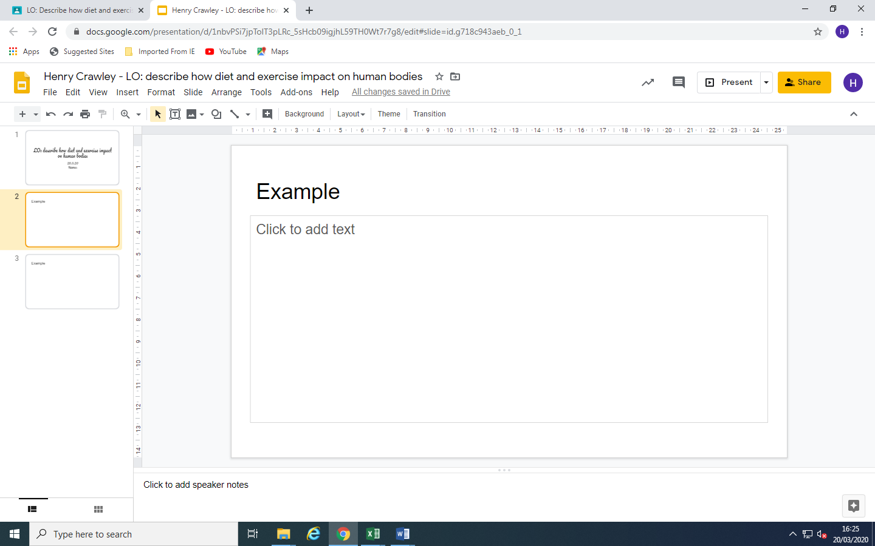
Complete your assignment. No need to save it… It does it AUTOMATICALLY!

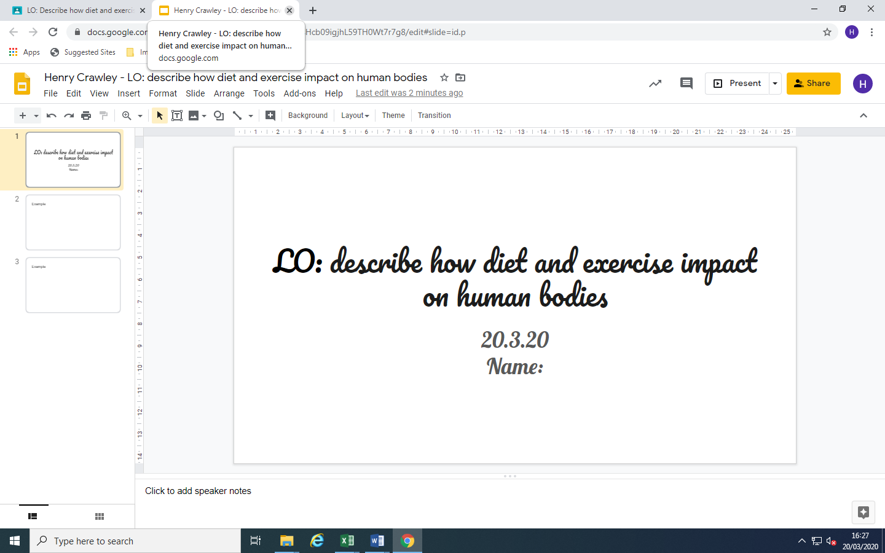
When you have finished, simply close the tab. (Check that your work is saved by reopening the file.)

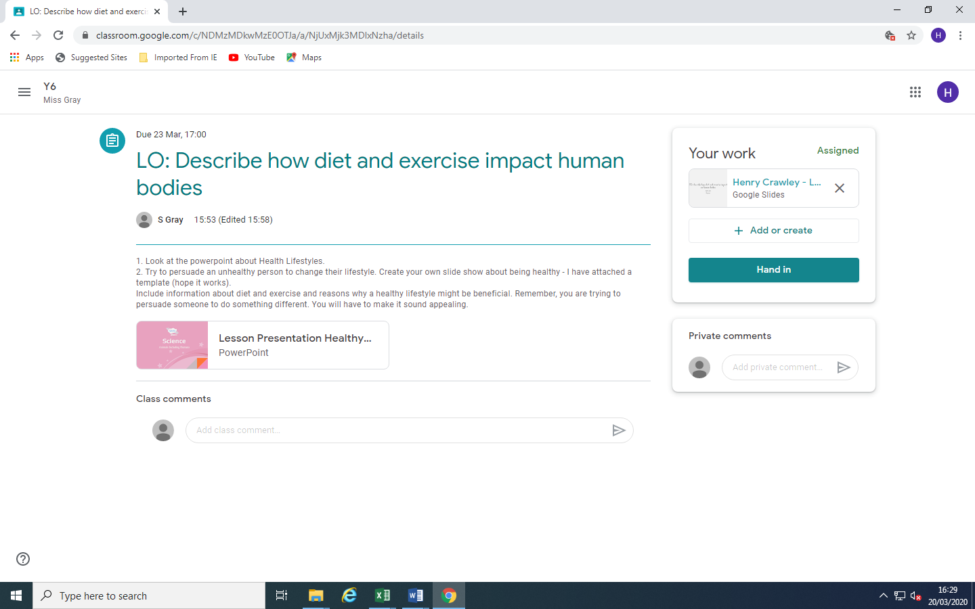
When you are happy that your work is as good as it can be, click to hand in.

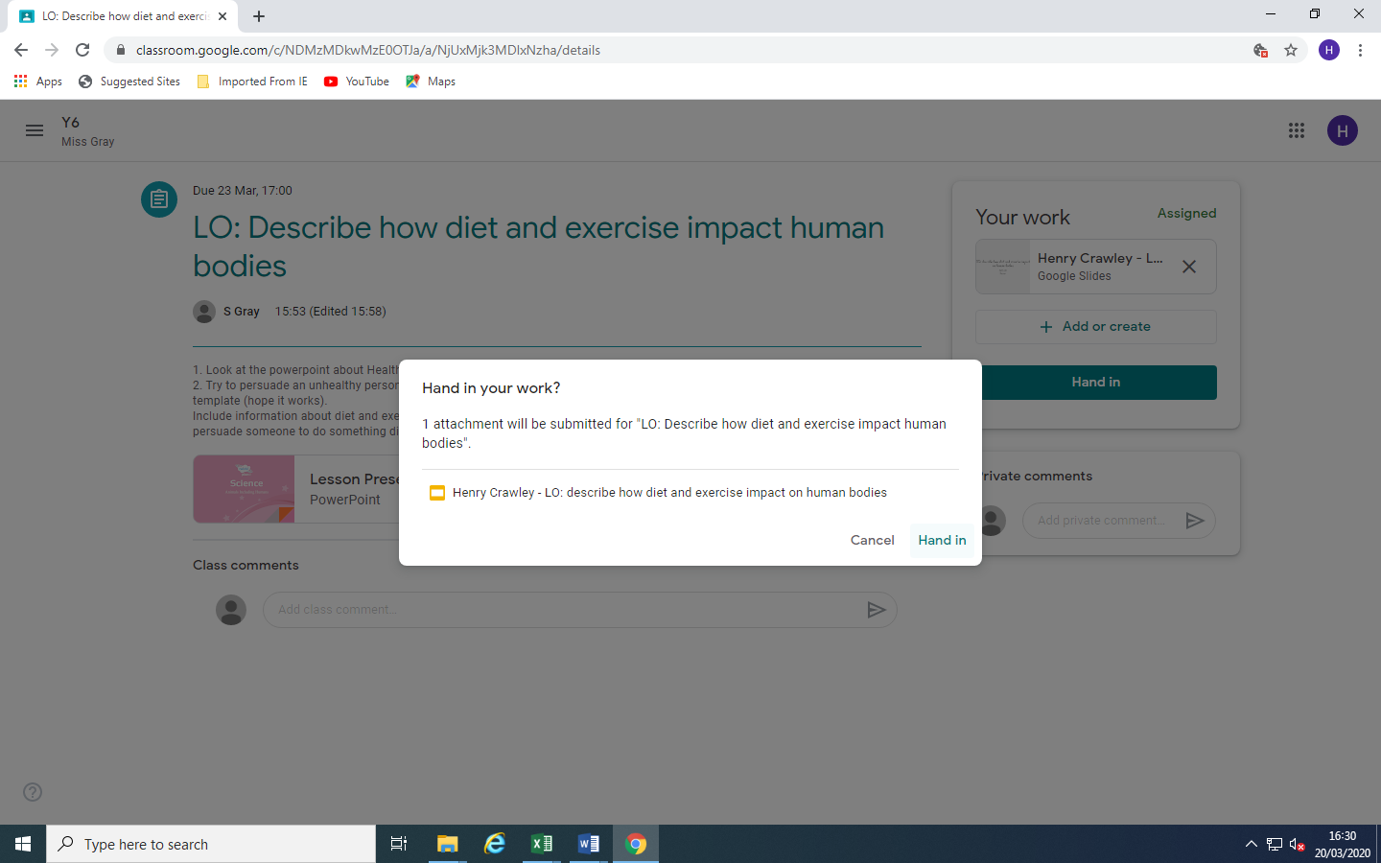
It will double check that you are happy. Click hand in if you are.

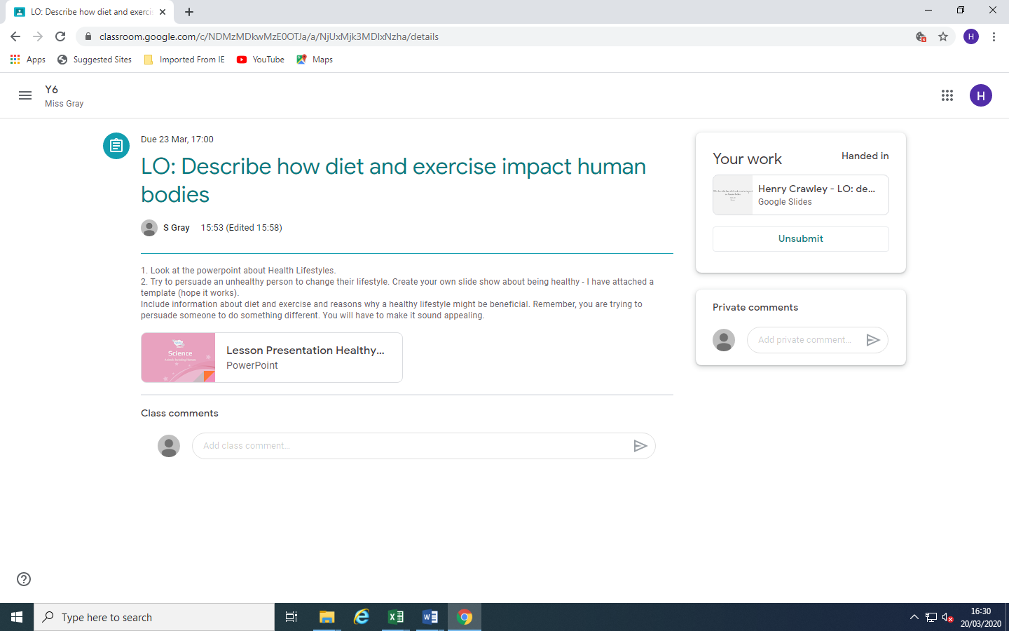
If you change your mind, you can unsubmit. This work is now done and handed in. You can come out of this and crack on, or have a brain break.

