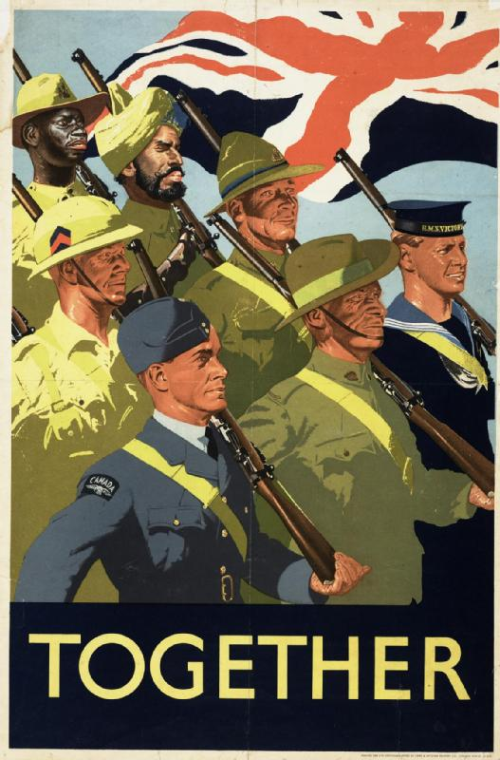
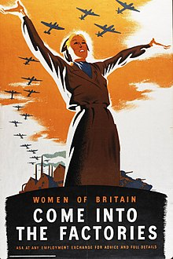

As Musicians we will be:
- Learning to sing and use instruments to perform Happy.
- Explore tempo, parts and music notation.
- Use improvisation to explore the Jazz genre.

As God’s Children we will:
- Be learning about unconditional love and how God loves us because we are his children.
- Exploring vocation and commitment, choosing a religious life and the sacraments of Baptism and Confirmation.
- Exploring expectations linked to the Advent period.

As Computer Technologists we will:
- Learning how to stay safe on-line.
- Testing credibility of sources on-line.

As Artists we will:
- Using sketching techniques to explore form and proportion.
- Conveying emotion through sketching and painting.
- Evaluating existing works of art to understand techniques used.
As Scientists we will:
- Learning about classification of plants and animals.
- Learning about human anatomy and physiology
- Asking scientific questions
- Planning and carrying out investigations, making observations and drawing conclusions from results.
As Mathematicians we will:
- Learning about the properties of number and place value up to 10,000,000.
- The four operations including long multiplication and division.
- Fractions including adding, subtracting, multiplying and dividing.
- Position and direction including translations and reflections.
- Reasoning and problem solving.

As Writers we will:
- Writing character descriptions, playscripts and letters based on historical stories.
- Reading and finding connections between stories by significant authors.
- Learning a wide range of spelling and punctuation to use within our writing.
- Using word processing to edit and improve our work.
In PSHE we will:
- Learning about body image and linking this to advertising and media.
- Learning about body changes during puberty.
- Learning about human reproduction.
- Understanding ways that we can keep safe.

As Athletes we will:
- Learning to play tag rugby and hockey.
- Learning to jive and choreograph our own routines.
- Perform controlled gymnastics sequences using a range on movements and apparatus.

Year 6
Autumn
World War 2
In Topic (History and Geography) we will:
- Learning about key events within WW2.
- Exploring causes and how events changed life following the war.
- Learning about the lives of key figures during WW2.
- Exploring different viewpoints of events during
- WW2.
- Asking our own historical questions and using research to answer them.

