St Pius X Catholic Primary School



POSITIVE BEHAVIOUR POLICY

“Together in God’s loving family, we believe, we learn, we grow.”

Last Revision Date: | September 2023
Date of this Revision: | November 2024
Date of Next Revision: | November 2027

Contents

 | Page/s
School Values and School Ethos | 3
The 4 Learning Powers | 4
The Zones of Regulation | 5
A Relational Behaviour Model | 6
General Expectations | 6
Effective Feedback techniques | 7 - 9
The silent hand signal - checklist | 10
Viewing behaviour as a learning process | 10
St Pius X’s general responses to mistakes and incidents | 11
Using logical consequences | 12-13
Ways to Record Incidents of Concern - using CPOMs | 14
Harm from dysregulated (stressed behaviour) | 14
Risk Assessment Process | 15
Physical Intervention (control and restraint) - the use of reasonable force | 15
How we support children with additional SEMH needs | 15 - 16
Our Principles - the things we do as adults | 16 - 17
Further Guidance - links to support | 18
Appendices:  Appendix 1 - Risk Assessment Template  Appendix 2: 5P Plan Template  Appendix 3: A - B - C Approach to Behaviour  Appendix 4: Predict and Prevent  Appendix 5: Anxiety Mapping - Blank  Appendix 6: Anxiety Mapping Guidance  Appendix 7: Environmental Checklists for children with additional SEMH needs | 19

School Values
At our school we believe in the importance of relationships, ensuring children and young people feel valued, safe and secure, providing a sense of connection with members of staff and belonging to the whole school community.
St Pius X Catholic Primary School educates pupils to:

- Learn the Catholic faith and follow in the footsteps of Jesus Christ.
- Grow spiritually, academically and socially.

Everything we do at St Pius X is underpinned by our six school values. Based on the Beatitudes, they have been linked with inspiring role models who embody the following values:

- Integrity - Martin Luther King
- Fairness - Rosa Parks
- Peace - Malala Youzafsai
- Kindness - Mother Teresa
- Forgiveness - Pope Francis
- Service - David Attenborough
St Pius X’s values reflect those of the Essex Approach to understanding behaviour and supporting emotional wellbeing known as Trauma Perceptive Practice (TPP): compassion and kindness; hope; connection and belonging
We endeavour to make sure that our school values run through all the school policies and practice and children are celebrated for exhibiting them in our weekly Celebration Assembly through certificates and house points.
School Ethos
It is a core aim at St PIus X that every member of the school community feels valued and respected, and that each person is treated fairly and well. We are a caring community whose values are built on mutual trust and respect for all. This Relationships and Behaviour policy is therefore designed to support the way in which all members of the school can live and work together in a caring way. It aims to promote an environment where everyone feels happy, safe and secure, and able to learn.
We value each individual child and work with families, the community and beyond to offer diverse experiences and support. We develop children and young people to be confident, life-long learners and compassionate, respectful members of their community and the world. We always prioritise the safety of our children and young people and staff. Everything we do in school is underpinned by our safeguarding procedures.
We recognise that children have a ‘window of tolerance’ within which they feel safe, secure and regulated. When asked to do something outside of this window they can experience stress and react accordingly. Our aim is to help our children to widen their window of tolerance through teaching them about the stress-response in the brain and how they can learn to self-regulate through co-regulation with adults.

Building Learning Powers
At St Pius X Catholic Primary School, we believe that it is our role to develop a habit of lifelong learning within our pupils. In order to achieve this, teaching must work to strengthen four key learning muscles/behaviours:

Resilience:
Absorption – Teaching must engage pupils so that they are able to be absorbed in what they are doing
Managing Distraction – Pupils must be enabled to recognise and reduce distractions; they must recognise the best environment in which to learn
Noticing – Pupils must be able to perceive subtle nuances, patterns and details in their experiences.
Perseverance – Pupils must be able to keep going in the face of difficulties and challenge the energy of frustration productively.

Resourcefulness:
Questioning – lessons must encourage the children to ask questions of themselves and others
Making links – pupils should strengthen the ability to see connections between disparate events and experiences
Imagining – pupils will strengthen their ability to use imagination to explore their learning
Reasoning – pupils must be able to think logically, construct arguments and spot flaws in the arguments of others
Capitalising – pupils must be able to access and use the full range of resources from the wider world.

Reflectiveness:
Planning – identify all the issues that may be encountered
Revising – change plans where necessary, monitor and review progress and identify new goals
Distilling – look at what is being learned and be able to identify the essential features
Meta learning – pupils must develop a self-awareness of their learning styles, how they learn best and be able to talk about the process

Reciprocity:
Interdependence – know when it is appropriate to learn individually or collaboratively
Collaboration – pupils must be able to manage themselves in collaborative ventures and respect other points of view
Empathy & listening – contribute to others experiences by listening carefully
Imitation – constructively adopt methods, habits or values from those who are observed

Staff will praise pupils with specific language to celebrate how they have achieved these behaviours. Staff will also give house points to children demonstrating these learning powers.

Certificates will be given out in Celebration Assembly to celebrate pupil achievement in the 4Rs.

The Zones of Regulation
The Zones of Regulation is a whole-school strategy, which enables children to be able to identify their own emotions, whilst supporting them with strategies to self-regulate. These include: use of language / application of colours to feelings / considering their response to these feelings and calming and regulating activities. It is delivered through regular whole-class teaching sessions, as well as through more bespoke interventions - in response to individual need.
This approach helps children to:
• understand themselves better
• rationalise their worries and/or concerns
• learn to co-regulate, through adult modelling techniques and strategies and consequently
• become better able to manage their own emotions independently – self-regulation.
The Zones of Regulation uses four colours to help children self-identify how they are feeling and to categorise this feeling into a colour zone. Children are taught that there is no “bad zone” to be in, but that the green zone is the most appropriate zone to learn effectively in.
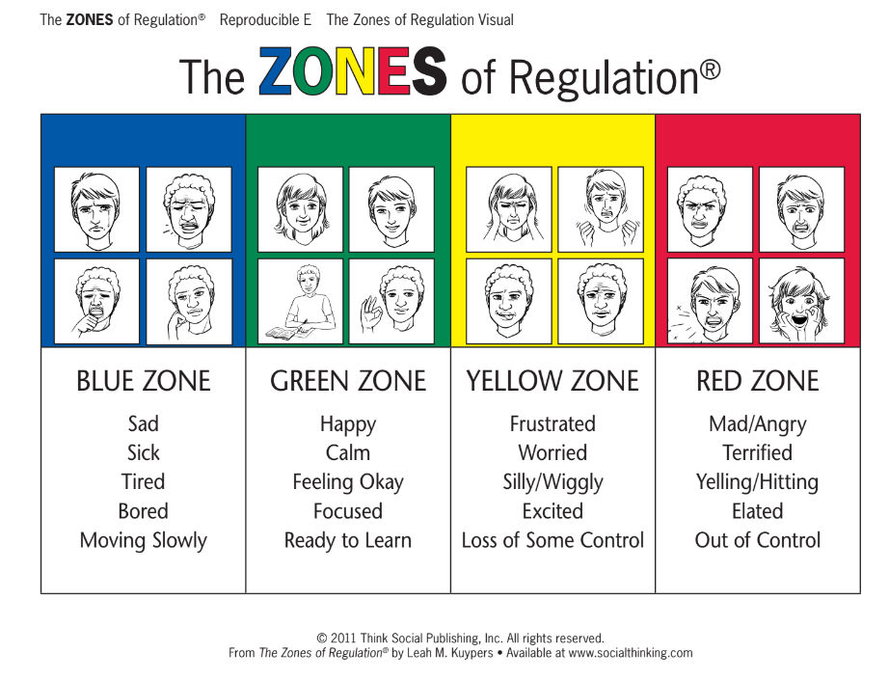

Children create their own “toolbox” which is full of strategies to help them regulate their emotions and move out of a particular zone. Adults also create this and display theirs in the classroom to model effective self-regulation.

A Relational Behaviour Model
At our school we adopt and use the relational behaviour model which is the approach from TPP. The key principles are as follows:
- Behaviour is something to interpret.
- Children are prone to make mistakes and highly responsive to the environment and context.
- Behaviour management is predominantly through relationships.
- Children who don’t manage should be understood and included.
- Boundaries and limits are to keep everyone safe and to meet everyone’s needs.
- Rules should be developed together and adapted where needed.
- Consequences are only used within a process of restore and repair.
- ‘Inappropriate behaviour’ is a sign of unmet need, stress (difficulty in coping), lack of understanding and skills.
- The causes of the difficulties are mostly in the environment and within the context of relationships.
- The solutions lie in understanding what the behaviour tells us about the child and their needs.
- Practice and policy effectiveness is measured by wellbeing and the capacity to adapt and make reasonable adjustments to meet the needs.

General Expectations
We have high expectations for our children, while recognising that some children have specific needs. The following expectations cover all times of the school day and where children are representing the school out of hours or off site. This means we:
- encourage a positive attitude to learning within a safe, happy environment
- promote high expectations and enable children to become independent responsible learners
- encourage a sense of respect for our community and our environment in line with our anti-bullying policy
- believe that clear, consistent routines and systems are essential to support children’s development and ensure the health, safety and wellbeing of everyone in our school community.
It is everyone’s responsibility to remind and support children where these expectations are not met. Equally it is important to comment positively when they are. Staff model expected behaviours, attitudes and habits.
Any behaviour that falls below the expectations of our school (e.g., disruption to learning, unkind or inconsiderate actions), will require some level of intervention. Remembering that every interaction is an intervention, it is important to remember that the strongest approach to support a child is through their relationship with the adult. At all points we try to ensure we keep a strong connection with the child having difficulties. We use positive recognition, as appropriate, to ensure the children know we are still there, and we recognise their effort and any changes they have made.
At our school, staff ensure good routines are in place for: start and end of the day; transition times, lining up (including assemblies); moving around the school; break and lunch times.
We use music to support transition times to create a calm, welcoming learning environment across the school.

Effective Feedback Techniques

To avoid low-level disruption and ensure that all children are engaged and on task, effective feedback techniques are used as part of daily classroom practice at St Pius X Catholic Primary School. The following guide has been shared with all staff members:

Effective targeted questioning
When to use:

Used as assessment for learning. Effective in most lessons to further develop higher attainers’ thinking and reasoning skills and also to support lower attaining children access the learning.

Use this developing questioning document to support with higher level questioning (in line with Bloom’s Taxonomy).

‘Build on Me’
Great to encourage lower attainers to share ideas. Teacher targets more basic questions (lower down on Bloom’s Taxonomy) to specific children and then asks another child to build on what they have said to develop ideas and thinking further.

Choose Two
When to use:

The ‘choose two’ strategy is best suited to a longer response to predictive/creative questions where there is no ‘right’ answer. It is however a very versatile strategy that can be used for most longer responses. If using for anything other than a predictive/creative answer, it is better that the choice of partners to respond not be ‘random’; you will have already heard ‘model’ responses from these pairs during partner talk time. Therefore this feedback strategy is only effective when some partner talk time has been given beforehand.

Example questions suited to this strategy:

- ‘What do you think Red Riding Hood will do when the wolf leaps out of the bed?’
- ‘What problems might Hansel and Gretel encounter when they enter the forest?’
- ‘If you were the Big Bad Wolf, how would you deal with the Three Little Pigs?’
- ‘What else could Bethany have done if Rumpelstiltskin hadn’t spun the straw into gold?’

Procedure:

After children have engaged in partner discussion, the teacher chooses two sets of partners (not individual children) to share their responses with the class. The teacher paraphrases/repeats them to clarify and gives specific praise if appropriate.
Choral Response
When to use:

The ‘choral’ strategy is best suited to a short response where there is only one correct answer. The question will therefore be very closed, possibly a 50/50 forced alternative. This feedback strategy differs from all the others in that you will rarely need to allow partner talk time beforehand. It is therefore the quickest of all the feedback mechanisms.

Example Questions suited to this strategy:

- What punctuation do we end a question with?
- How many bears were there in the Goldilocks story?
- Is ‘dog’ the subject or the object in this sentence?
- Is ‘mysterious’ an adjective or a verb?

Procedure:

The Teacher could indicate a choral response is needed in a number of ways, e.g by saying the first syllable of the answer or by saying ‘one, two, three’ after asking the question or by holding their hand to their ear. Children all give their response in unison.
Paraphrase
When to use:

The ‘choose two’ strategy is best suited to situations where a long response is required and there is one or more ‘right’ answers. It is however a very versatile strategy that can be used for most longer responses. This strategy is unlike all the others in that it is the teacher alone feeding back. The key point of it is therefore to allow the class to hear a ‘model’ or ‘ideal’ response. It can therefore be used to lead everyone in the correct direction, or to ‘plant’ the right idea should the children not be able to arrive at it themselves!

Example questions suited to this strategy:

- ‘What impact does this simile have on the reader?’
- ‘Why does personification make writing more descriptive?’
- ‘Why has the author chosen to use a metaphor here?’
- ‘How can you tell this is an adverbial phrase?’
- ‘Why is this written in the passive voice?’

Procedure:
As the children engage in partner discussion, the teacher listens to a few pairs and then paraphrases (or claims to have heard!) the best response to the class.

Word Wave
When to use:

The ‘word wave’ strategy is best suited to a short response with a range of possible answers. The question will therefore be more open than with the ‘choral’ strategy. This feedback strategy is most effective when some partner talk time has been given beforehand.

Example questions suited to this strategy:

- What adjective would best describe how Cinderella felt when she couldn’t go to the ball?
- What synonyms can you think of for ‘big’?
- What adverb describes how Red Riding Hood crept up the stairs?
- What would you be able to see if you were on this beach?
- What sounds might you hear in a street market?

Procedure:
After the children have engaged in partner discussion or had some silent thinking time, the teacher passes their arm over each child in turn. Only when the teacher’s hand is over them does the child offer their response. The others remain silent until it is their turn.
Popcorn
When to use:

The ‘popcorn’ strategy is best suited to a short-medium response with a range of possible answers. Unlike a ‘word wave’, it does not require the teacher to move around the room. It also allows children to potentially give slightly longer responses than would be possible with a ‘word wave’. This feedback strategy is most effective when some partner talk time has been given beforehand.

Example questions suited to this strategy:

- ‘What adverbial would describe how the cat crept towards the house?’
- ‘What word would work instead of “shocked” in this sentence?’
- ‘What are the features of an instructional text?’
- ‘What phrase could we replace “upset” with to “show” instead of “telling”?’

Procedure:

After the children have engaged in partner discussion or had some silent thinking time, the teacher passes their arm over each child in turn. Only when the teacher’s hand is over them does the child offer their response. The others remain silent until it is their turn.

Variations:

- By table/row: for medium length responses (e.g. ‘what do you think Jack found as he opened the door to the giant’s house’) eliciting answers from each table or row via ‘popcorn’ can be a much quicker and more inclusive alternative to ‘take two’, ‘paraphrase’ or the traditional ‘hands up’.
- Partner 1/Partner 2: As effective ‘popcorn’ does require perseverance on the part of the teacher and training on the part of the children, a stepping stone to ‘whole class popcorn’ can be to separate the class in half via ‘partner 1’ and ‘partner 2’ and elicit answers from each half separately.

Whiteboards
Quick and easy way to assess children’s understanding. Teacher asks a question for all and the children then show it on their whiteboard.

It is then important for the teacher to use targeted questioning effectively to further develop specific children’s understanding.

Group responses - Actions
Can be effective as an assessment tool and when providing children with a question with two clear choices. The teacher decides on an action for the child to do to represent an answer (touch your head or fold your arms). The teacher then shares the two choices, the children have thinking time and then show their action.
Can be an effective way to get all children involved and when a snappy answer is needed.

Example questions suited to this strategy:

- ‘Which word do we think better describes how the character walked: sauntered or trudged?’
- ‘Do you think Jack should have sold his cow for some magical beans?

You can then target your follow-up questions accordingly (asking the children to justify etc.) based on the binary responses you received.

Silent Hand Signal

At St Pius X Catholic Primary School, we use the silent hand signal to stop children and get their attention. We use this across the school to ensure a consistent approach from EYFS to Year 6.

Silent Hand Signal Procedure:
Adult smiling
Adult raising hand and not talking
Domino effect as children return the signal
All return the signal - eyes look, hands still
Adult scans to check that all have stopped
Adult drops hand when all are silent and only then talks
All adults in the room should raise their hands as well

The signal is used in lessons, assemblies and at break and lunch times. All adults model the signal to ensure that all children are listening.

Viewing behaviour as a learning process
At St Pius X, we accept and understand that learning how to regulate our behaviour is a learning process. At times children will push limits, boundaries, and societal norms as part of their normal development. They may also react in different ways to stress, boredom, lack of understanding, over-excitement, and disappointment. Using the relational model, we offer support, help and guidance to the child along with co-regulation so they can develop strategies to regulate themselves and develop resilience for the future. It is our role, as fully developed adults, to help guide children to make helpful and positive choices when they can by relating to them and helping them to restore and repair as required. We know that this is the best way to respond to our child’s behaviour and maintain our relationship with them.
The approach we strive for is based on the premise of ‘connection before correction’.
St Pius X’s general responses to incidents
At St Pius X Catholic Primary School, we believe that all behaviour is communication and in the power of using restorative approaches. Such processes do not shy away from using consequences where logical, appropriate and proportionate. They also focus on the need to take responsibility for finding a constructive way forward for all concerned. This might mean a sincere apology followed by an act of kindness.
Such approaches encourage the child in our school to reflect and consider not only the consequences of their actions on themselves, but also the impact of their actions on others. We also support them in developing strategies to help the child to regulate themselves (using the Zones of Regulation) to avoid the situation happening again in the future.

In using this process at our school, we use four questions:
• What happened?
• What were you feeling or thinking at the time?
• Who has been affected?
• What can we do to make things right? (What should happen next?)

As part of the restore and repair process, they have the chance to show the person that has been affected by their action that they are sorry. This can be in the form of verbal, written, picture, or an action.
Where possible, a logical consequence (natural reparation) is used e.g., clean graffiti off the door, clean up the mess, pay for replacement of items. Where this is not possible a close alternative should be used.
At St Pius X, the staff work with the child using the Zones of Regulation so that they understand how their brain works and reacts to stress responses. By doing so, we provide them with the opportunity to recognise when they are becoming dysregulated and assist them (using co-regulation) in developing self-regulation strategies for the future.
By developing new strategies, this ensures that they have learnt from an incident so that they can be more successful next time. The impact of our approach is evident in the relationships forged throughout the school.

Using logical consequences
The use of consequences

Consequences can be a useful response to behaviours, remembering that some behaviours result in positive consequences. When responding to unwanted behaviour, the consequences we use at St Pius X, always look at the incident with the knowledge of the stress response (and how the brain reacts), the relational model and with the aim to repair and restore through relationships.

We view consequences as protective and/or educational. Best practice suggests that all protective consequences should run alongside educational consequences, as it is unlikely that long-term change will occur without this.

Protective consequences: these are required to protect the rights of others and keep a child safe.

At St Pius X, this may include:

- co-regulation to help develop self-regulation strategies
- increased staff ratio
- change of school day/timetable
- arrangements for access to outside space
- child or young person escorted in stressful situations
- differentiated teaching space
- appropriate use of exclusion (using the time to educate on the Zones of Regulation, using co-regulation to develop self-regulation strategies; reflect, amend plans and identify needs and other appropriate interventions to support.)

Educational consequences: at St Pius X, we use these to teach, encourage, support and motivate the child to behave differently next time though better understanding. These should always be logical, appropriate and proportionate.

Examples include:

- ensuring the child completes the task they have disrupted
- rehearsing/modelling situations through intentional teaching of prosocial behaviour
- ensure the child assists with repairs where they have caused damage (when possible and practical)
- intentionally provide educational opportunities for the child to learn about the impact of certain actions and behaviours
- providing the child with an opportunity to ‘put things right’ through a process of reflecting, repairing and restoring relationships.

Logical Consequences at St Pius X:

Level 1 - low level disruption | Level 2 - disrespect of others or property | Level 3 - anti-social behaviour  Report to Key Stage Leader | Level 4 - aggressive, violent and threatening behaviour  Report to DHT / HT
Actions | Actions | Actions | Actions
Interrupting the lesson  Not on task, wasting time  Talking while the teacher is talking  Distracting behaviours: flicking, throwing, unnecessary noises, gestures or actions  Dropping litter/food  Not allowing children to join in games  Interfering with another person’s property  Not lining up properly  Being inside school at playtimes without permission  Talking in assembly  Not completing sufficient work within the lesson | Persistent Level 1 behaviours  Not accepting instructions/deliberately  not completing task set  Minor damage to property  Disrespectful dialogue about another child or adult  Swearing in a non-aggressive way  Making fun of another child/deliberately provoking them  Lying in order to get another into trouble  Throwing or flicking things in the classroom  Misuse of toilets  Play fighting  Leaving the room/playground without permission | Persistent Level 2 behaviour  Any form of fighting and intentional physical harm  Persistent refusal to follow adult instructions  Unsafe behaviours  Verbal abuse to any child or adult (including racial abuse)  Leaving the school site without permission  Stealing another person’s or school property  Damaging property  Swearing at another person | Persistent Level 3 behaviour  Causing serious physical harm  Serious racial abuse  Child on child abuse (DSLs use Brook Traffic Light grid)
Consequences | Consequences | Consequences | Consequences
Ignore low level disruptive behaviour and reinforce positive  A quiet word from staff with the emphasis on what should have been done  Reminder of our school values and the 4Rs  Completing work at playtimes with an adult (if sufficient work has not been completed) | As well as Level 1 consequences,  Talk from staff about what should have been done  ‘Time to Think’ within the classroom - restorative time to regulate emotions  Restorative Approach  Parents informed by CT | As well as Level 2 consequences,  Reflection Time (at break/lunchtime -how to repair the situation e.g. written/verbal apology) | As well as Level 3 consequences,  Suspension (HT will make a case by case assessment)  Internal exclusion  Removal from lunch time for a period
Any Follow-up Actions by Adults | Any Follow-up Actions by Adults | Any Follow-up Actions by Adults | Any Follow-up Actions by Adults
Use Zones of Regulation to help support children with regulating emotions  Restorative conversations should reference the 4Rs or our School Values | Use Zones of Regulation to help support children with regulating emotions  Restorative conversations should reference the 4Rs or our School Values  Parents informed by CT (if behaviour has been persistent for a week) | Incident recorded on CPOMs  Report incident to Key Stage Leader and parents  Mini behaviour plan / targets set by class teacher - individualised to pupil | Incident recorded on CPOMs  Incident reported to the DHT / HT who will speak to the parents  5 Plan needs to be created for child  5 P Planning meeting to be arranged with parents, teacher and SENDCo

Ways to Record Incidents of Concern - using CPOMs

At St Pius X Catholic Primary School, we use CPOMs to log any incidents relating to behaviour. All behaviour incidents should be logged as soon as possible (lunch/end of the day).

Incident logs are not for low level disruption unless it is on-going - see the consequences at St Pius X table above for examples of behaviour.

Things to remember when using CPOMs:

- All comments should be factual (opinions should not be added):
- What did you directly observe?
- What did the child say / do?
- How was the observation acted on?
- Do not comment on previous incidents - just report the current incident.
- Emotive language should not be used.
- Exclamation marks should never be used - punctuation should not portray any emotion.
- Incidents should be written by the adult who observed the incident (teacher / TA / HLTA / midday staff).
- All incidents should include a follow-up action.
- Incidents should include alerts to other relevant staff - always alerting SLT.

All incidents are monitored by SLT and further actions will be added as required.

Click here for a more comprehensive user guide to CPOMs.

Harm from dysregulated (stressed) behaviour

St Pius X Catholic Primary School always prioritises the safety and welfare of all staff and children, recognising that everyone is entitled to a safe and supportive environment. Any incident (verbal or physical) which compromises safety can be perceived as harmful. Our staff understand through training that this behaviour is not necessarily deliberate, rather it is often due to a stress response.

Supporting those who have been harmed

Our staff and children receive the individual support they need in response to any incident where the behaviour has compromised the wellbeing of someone else, causing harm. Occasionally there may be times, despite all reasonably practicable measures being taken, when prevention is unsuccessful, and someone is harmed. At these times our school ensures that this person (adult or child) is fully supported.

We always consider the following:
- are they physically safe and protected?
- do they need immediate first aid & medical treatment?
- is there a need for immediate police involvement?
- ensure they have the opportunity to talk about the incident either with a trusted person or other independent service
- give reassurance to reduce feelings of guilt and/or anxiety

Risk Assessment Process

At St Pius X Catholic Primary School, we use a risk assessment process as the starting point for preventing harm for identified vulnerable children. It identifies what is likely to cause stress to them, using all the information known about them. This information is collated so that individualised targets, in the form of a 5P plan, can be created to support the vulnerable child and other children and adults in the learning environment. The risk assessment template can be found in Appendix 1.

Physical intervention (control and restraint) - the use of reasonable force
At St Pius X Catholic Primary School, we make sure we are aware of our duties of care and follow the law. The law states that it is permissible to use reasonable force to prevent children committing an offence, injuring themselves or others, or damaging property, and to maintain good order and discipline in the classroom. The latest guidance from the DfE can be found here: DfE Behaviour in Schools September 2022

The use of physical intervention techniques is only one aspect of co-regulation and is usually the last resort when it is deemed absolutely necessary. It may resolve a short-term situation, but the long-term aim must be to help the child or young person to be able to self-regulate during times of stress.

If such actions are necessary, the actions that we take aim to use the minimum amount of force necessary for the minimum amount of time necessary. Where physical intervention is needed, this is recorded and reported immediately to the head teacher.

Where it has been deemed necessary to use a restrictive physical intervention, the detail of this should be accurately recorded and the incident communicated to parents. Parents should be informed of the incident initially by phone and it should then be followed up in writing.

How we support children and young people with additional Social, Emotional and Mental Health needs

At St Pius X Catholic Primary School, we acknowledge that some children will have, at times, additional needs. We recognise that children may experience a range of social, emotional, mental health needs which present themselves in many ways. These may include children displaying challenging, disruptive or stress-related behaviours. These behaviours may also reflect underlying social interaction difficulties, sensory or medical needs or clinically diagnosed needs such as attention deficit disorder, attention deficit hyperactive disorder, foetal alcohol disorder or attachment difficulties.

We will always endeavour to understand behaviour, support emotional wellbeing and make reasonable adjustments to our provision to support progress and engagement using a variety of strategies developed with key adults within the child’s life (staff, family, professionals) in order to best meet their needs. In Essex, this is done in the context of One Planning. We also recognise the needs of children and young people with Special Educational Needs and Disabilities (SEND) and follow the policies and procedures associated with supporting these children and young people, including but not limited to, the SEND code of practice, Equal Opportunities and Disability Act.

We understand that the communicating behaviour(s) most likely comes from a place of stress which may come from anxiety, fear or as a result of a barrier to learning. We have a duty to strive to help children and young people to return to a place of regulation, within their ‘Window of Tolerance’, as only then will the child or young person be in a place to learn, connect and thrive.

Ways to Support Understanding

At our school we believe that understanding what the behaviour is communicating to us is the first part for planning a response.

Our Principles - the things we will do as adults:
All staff
- Seek to understand the communication behind the behaviour - using the A - B - C approach to support (see Appendix 2) and anxiety mapping (see Appendices 3, 4 & 5)
- Keep the relationship at the forefront when seeking to restore and repair (connection before correction)
- Model compassion and kindness, provide hope and support, connection and belonging
- Understand that any event in a child or young person’s life can impact on how they think, feel and act
- Use of logical (natural) consequences rather than just simply punishments or sanctions
- Provide routines, set limits and have clear boundaries
- Regulate our own emotions
- Co-regulate with young people and help them to develop self-regulation strategies for the future.

Head Teacher
- Leads on all aspects of this policy and model the expectations for all staff
- Ensures that all staff receive regular purposeful training to support relationships and minimise risk
- Ensures that all staff are provided with clear instructions for reporting incidents of harm and that all such reports are thoroughly investigated and responded to
- Ensures that risk assessments are carried out when required and that appropriate measures are implemented
- Is the only person authorised to suspend or exclude a child or young person (or the Deputy Headteacher in their absence)

Other Senior Leaders
- Lead on all aspects of this policy and model the expectations for all staff
- Ensure the policy is implemented effectively
- Ensure all staff are appropriately trained
- Oversee the specific needs of all children and young people across the school
- Provide support to staff, children and parents/carers as necessary
- Link with outside agencies to access additional services
- Ensure that all tracking and reporting of incidents and additional needs are up to date

Classroom Staff
- Plan the teaching and learning for all children
- Include parents/carers in personalised planning for their child
- Communicate regularly with parents/carers about their child’s needs
- Provide specific support for children and young people experiencing any difficulties, whether this is an ongoing need or a short term difficulty a child may be having.

Family
- Inform the school of any concerns about changes in their child’s behaviour, emotional wellbeing or mental health
- Have open conversations with the school
- Engage with support offered by the school and other agencies to further support their child’s needs.

Governors
- Ensure that appropriate policies are in place, that they are regularly reviewed, and their effectiveness monitored
- Undertake their statutory role around suspension and exclusion
- Ensure that all staff receive purposeful training in order that they can undertake their role

Further Guidance

1. Keeping children safe in education Sept 2022

2. Behaviour in schools guidance Sept 2022

- Reducing the Need for Restraint and Restrictive Intervention June 2019

- Suspension and Permanent Exclusion Sept 2022

- Positive environments where children can flourish (2021)

- Creating a Culture: how school leaders can optimise behaviour (DfE, 2017)

Appendix 1: Risk Assessment Template

Adopting precautionary and preventative steps which help to avoid, prevent, minimise or mitigate incidents where staff can be harmed. Maintaining a sense of proportion in relation to the assessed risk. All incidents are recorded on CPOMs. This risk assessment should be used in conjunction with a child’s individual 5P plan, which will have been discussed with parents / carers.

Date: Child’s name: Relevant adults:

What harm could occur and how severe could this be? How likely is this harm?
What information is provided for staff, how is it communicated?
Is there any additional training needed for relevant staff?
Are there changes needed to the way people carry out their duties or where they work?
When and where is the child most likely to become dysregulated (including activities and areas?
What preventative measures are in place?

Risk assessments should be reviewed and updated termly by the SENDCo. It also should be visited again following a significant incident to reflect on any learning or additional protective measures.

Appendix 2: 5P Plan Template - click here for editable version
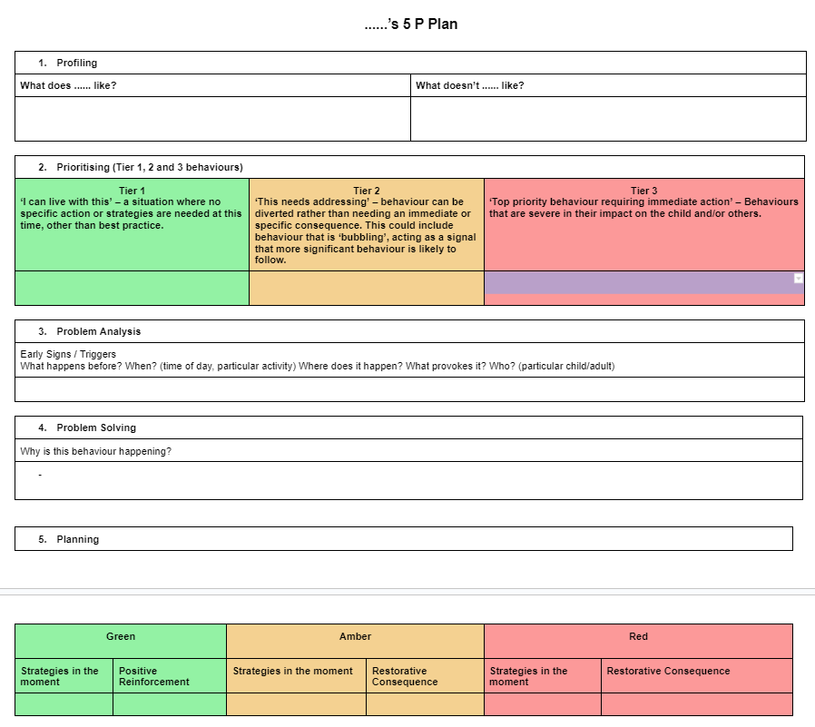

Appendix 3: A - B - C Approach to behaviour

Name: | Date: | Staff name:
General description of behaviour:
Antecedent | Behaviour - What did the child actually do? |  |  | Consequence
A | B | B | B | C
Questions to consider:  What happened before?  When? (particular activity)  Where? (environment: temperature, noise level, lighting, time of day, space, proximity of others, clothing)  What provoked it? - (knowing the child’s difficulties, how could one of the above have caused his/her behaviour?)  Who? Adult / Child | Questions to consider:  What were the first signals? (early indications)  These could be amber behaviours or displaying that they are in the Yellow Zone. | Questions to consider:  What were the first / emerging behaviours?  (increasing problem indicators or “bubbling” behaviour)  These could be further amber behaviours or displaying that they are in the Red or Yellow Zone. | Questions to consider:  What were the final stage behaviours? (the most severe) | Questions to consider:  What strategies were used as a result of the child’s behaviour?  What happened next?  What will you do next?  Restorative Conversation?
Length of behaviour episode:

Appendix 4: Predict and Prevent - Anxiety Mapping
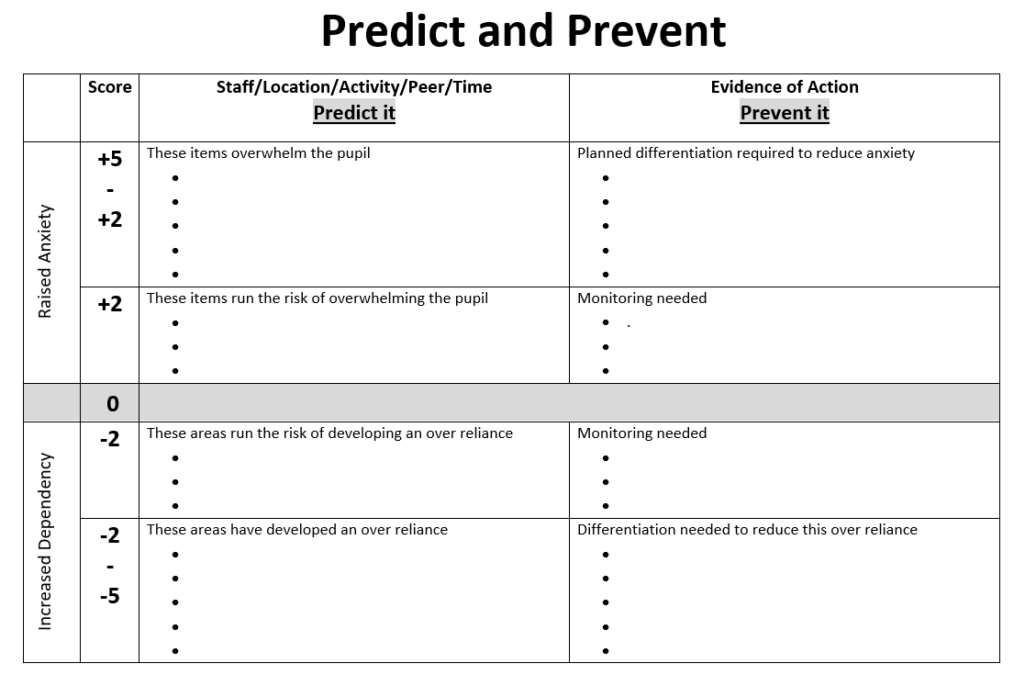

Appendix 5: Anxiety Mapping - Example:
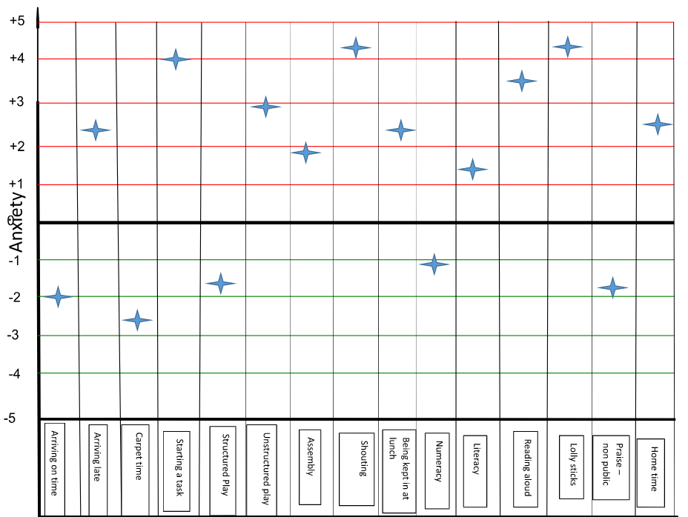

Time / location / staff / activity etc

Appendix 6: Anxiety Mapping Guidance
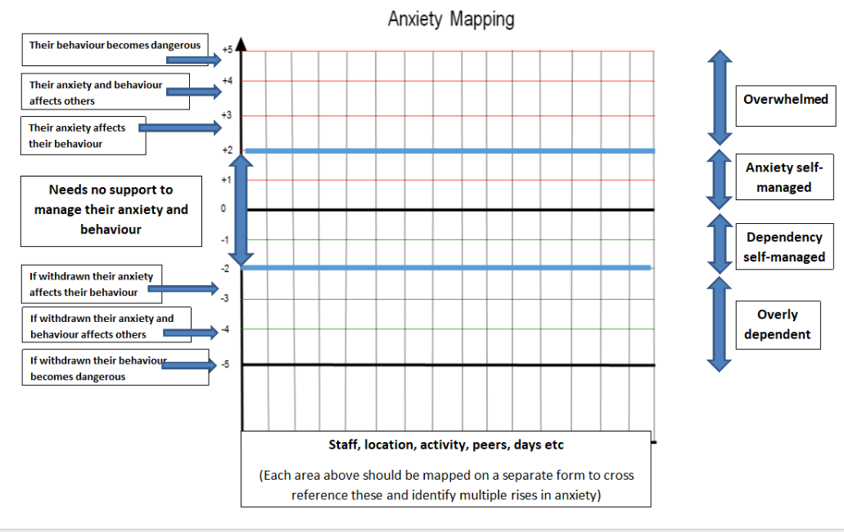

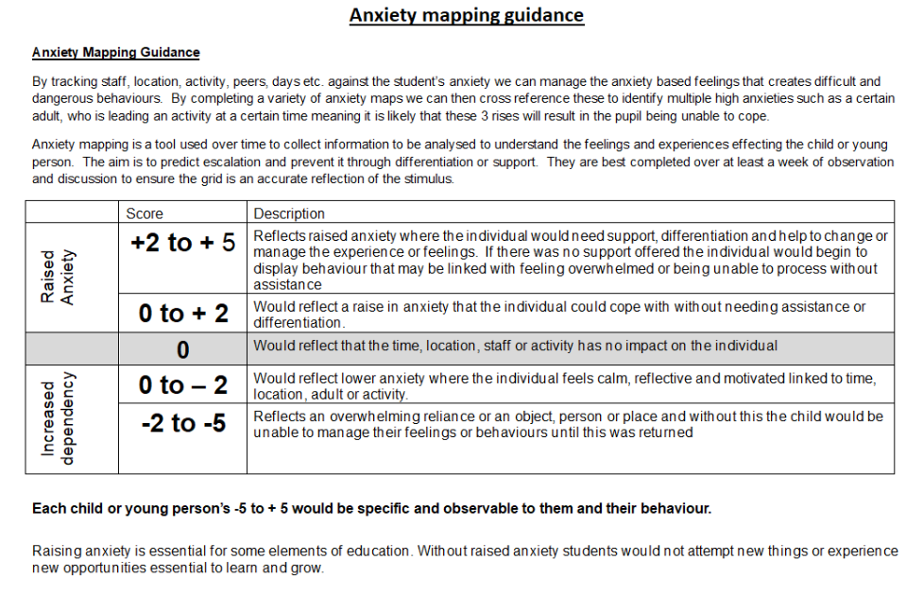

Appendix 7: Environmental Checklists for children/young people with additional Social Emotional and Mental Health (SEMH) needs
Consider the needs of a specific child/young person before exploring the school environment with them in mind.
The questions are designed to be prompts to inform One Planning.
The individual checklists complement each other, but separate different school environments in order to consider a child’s presentation in different contexts thus drawing attention to differences and similarities. Some questions are therefore repeated.
Safety | Y/N n/a | What needs to be done
If deemed appropriate, has a risk assessment been completed to assess and manage risks involved in the provision for the child?
Have actions been taken to address identified risks?
Have staff received appropriate training as part of addressing identified risks?
Have parents/ carers been involved in the assessment and planning to support the safety of their child in school?
Have parents/carers been informed of any incidents where safety of their child has been of concern?
Is the child feeling secure in their relationships with adults and peers?
(see Social Interaction section)

The SEND Environment | Y/N n/a | What needs to be done
Has a One Page Profile been completed for this child?
Are procedures in place to share the One Page Profile with familiar adults and those unfamiliar with the child eg. supply teachers?
Is One Planning in place for this child?
Is there a current Adult Response Plan in place for the child?
Are major/repetitive incidents or communicating behaviours which cause concern analysed so changes can be planned for? (using ABC analysis tools)
Has the school/setting communicated appropriately and effectively with the child’s parents / carers?
Does the child separate appropriately from parents/carers at the start of the day and return happily to them at the end of the day?
Are parents/carers requesting parenting support at home and have they been appropriately signposted?
Are there any outside agencies already involved in the support for the child?
If outside agencies are involved, have their recommendations been followed effectively?
Have interventions provided by outside agencies been delivered?

The Learning Environment | Y/N  n/a | What needs to be done
Have the child/young person’s views about their learning been sought?
Is the child able to access support quickly in the classroom when necessary?
Is a Learning Support Assistant directed to support the child?
Does the Learning Support Assistant have a good understanding of the child’s needs?
In line with best practice, does the Learning Support Assistant offer hover support?
Are there procedures in place to regulate and monitor the use of personalised provision if necessary?
Is there a safe place that the child can access within the classroom when necessary?
Is the child seated in a place that supports their needs eg. away from distractions or close to the exit?
Is the child able to attend to and engage with whole class learning?
Is the child seated with good role models and away from others who may prove distracting?
Is the child able to work effectively with peers in a group?
Is the child able to focus and complete independent work for an appropriate period of time?
Are adults using positive language around and to the child?
Are adults using the language of Growth Mindset to support the child?
Are the child’s feelings and emotions acknowledged?
Do staff react consistently to communicating behaviours?
Are rewards and consequences given fairly and consistently?
Is the child given access to sensory, movement or brain breaks when necessary?
Have the child’s sensory needs been explored? If so, has provision been made for them?
Does the child have good relationships with the adults in the classroom?
Does the child person enjoy being given responsibility?
Are there times when the child can focus on work for longer periods of time?
Are there specific subjects that the child finds more difficult to engage with, such as Literacy or PE?
Is the child able to work outside of the classroom when appropriate?
Is the child supervised adequately when out of the classroom?
Do all staff know how to react to the child and his/her communicating behaviour when encountering them in the school?
Is the child able to follow normal school rules and routines without additional supervision e.g. using the toilets appropriately, sitting with peers in assembly?
Is the child able to line up with their peers?

Does the child/young person have any other significant relationships with staff or children around the school?

Social interaction  (less structured environments) | Y/N  n/a | What needs to be done
Have the child’s views about friendships and relationships with adults and peers been sought?
Does the child have friends they can play with?
Is the child person able to interact appropriately with other children beyond their friendship group?
Is the child able to play safely and independently?
Are there systems in place that allow the child to access play opportunities eg. play leaders, equipment?
Are there alternative, more structured environments available within the school available to support the child eg. lunch clubs?
Does the child know how to access adult support in less structured environments?
Do the adults supervising have a clear understanding of the child’s needs?
Do staff react consistently to communicating behaviours?
Are rewards and consequences given fairly and consistently?

